 | CHAROTAR UNIVERSITY OF SCIENCE & TECHNOLOGY  DEVANG PATEL INSTITUTE OF ADVANCE TECHNOLOGY AND RESEARCH | 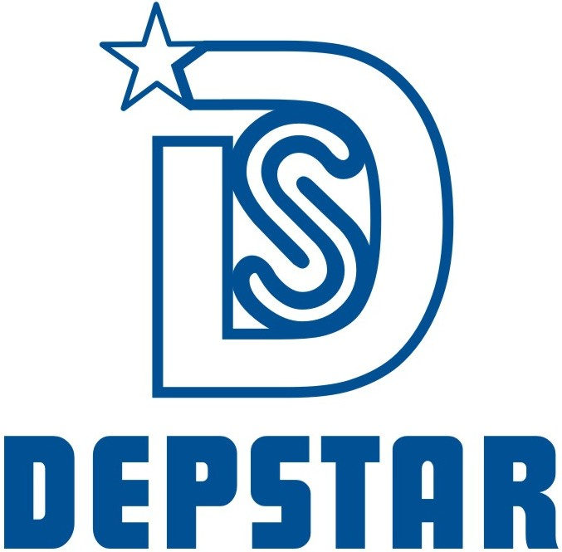

Week-5 Report

Student ID: 20DCE019 | Student Name: Yatharth Chauhan
From Date: 6/06/2022 | To Date: 11/06/2022
Semester: 5th | Internship ID:

Work done in last week (Attach supporting Documents):

Technology: UI-UX Design

- 06/06/2022 (Monday)
On leave
- 07/06/2022 (Tuesday)
Design LinkedIn cover page of DTech Studio Company
Confidential Design that’s why I can’t attached image.
- 08/06/2022 (Wednesday)
Design Create the LinkedIn Post of DTech Studio Company
Confidential Design that’s why I can’t attached image.

- 09/06/2022 (Thursday)
Start to Design the Book My Space Logo

- 10/06/2022 (Friday)
Completed the Book My Space Logo

- 11/06/2022 (Saturday)
Starting the video call web UI Design

Plans for next week:

- Nasa Industries Project

References:

https://dribbble.com/shots/15734650-LinkedIn-Cover-Design

https://dribbble.com/shots/17737667-Social-Media

Signature of External Guide Signature of Internal Guide

